Life, Level 3
2nd Edition

correlated to

English Proficiency Standards for Adult Education
Level 2

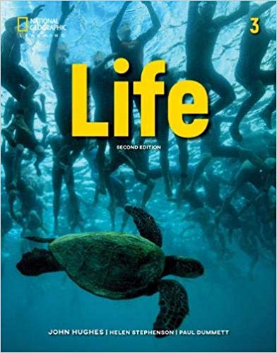

English Proficiency Standards for Adult Education, Level 2 | Life, Level 3
ELP Standard 1
An ELL can… construct meaning from oral presentations and literary and informational text through level appropriate listening, reading, and viewing.
By the end of English language proficiency level 1, an ELL can…
use an emerging set of strategies to:  - identify the main topic in oral presentations and simple spoken and written texts | 14, 62, 122, 134
- retell a few key details. | 134
ELP Standard 2
An ELL can… participate in level appropriate oral and written exchanges of information, ideas, and analyses, in various social and academic contexts, responding to peer, audience, or reader comments and questions.
By the end of English language proficiency level 1, an ELL can…
- participate in short conversations and written exchanges about familiar topics and texts | 13, 26, 50
- present information and ideas | 110, 122, 124
- appropriately take turns in interactions with others | 13, 35, 49
- respond to simple questions and wh- questions. | 28, 47, 61
ELP Standard 3
An ELL can… speak and write about level-appropriate complex literary and informational texts and topics.
By the end of English language proficiency level 1, an ELL can…
with support,  - deliver short oral presentations | 110, 122, 124
- compose simple written narratives or informational texts about familiar texts, topics, experiences, or events. | 41, 53, 137
ELP Standard 4
An ELL can… construct level appropriate oral and written claims and support them with reasoning and evidence.
By the end of English language proficiency level 1, an ELL can…
- construct a claim about familiar topics, experiences, or events | 125
- introduce the topic, experience, or event | 125
- give a reason to support the claim | 125
- provide a concluding statement. | 125
ELP Standard 5
An ELL can… conduct research and evaluate and communicate findings to answer questions or solve problems.
By the end of English language proficiency level 1, an ELL can…
with support,  - carry out short individual or shared research projects | 98, 149
- gather information from provided print and digital sources | 98, 127, 149
- record information in simple notes | 98, 127, 149
- summarize data and information. | 149
ELP Standard 6
An ELL can… analyze and critique the arguments of others orally and in writing.
By the end of English language proficiency level 1, an ELL can…
with support,  - identify the main argument an author or speaker makes | 101, 125
- identify one reason an author or a speaker gives to support the argument. | 101, 125
ELP Standard 7
An ELL can… adapt language choices to purpose, task, and audience when speaking and writing.
By the end of English language proficiency level 1, an ELL can…
- show increasing awareness of differences between informal and formal language use | 65, 76, 107
- adapt language choices to task and audience with emerging control in various social and academic contexts | 38, 97, 110
- begin to use some frequently occurring general academic and content-specific words. | 97, 110, 122
ELP Standard 8
An ELL can… determine the meaning of words and phrases in oral presentations and literary and informational text.
By the end of English language proficiency level 1, an ELL can…
using context, questioning, and knowledge of morphology in their native language(s),  - determine the meaning of frequently occurring words, phrases, and expressions in spoken and written texts about familiar topics, experiences, or events. | 139, 142, 151

ELP Standard 9
An ELL can… create clear and coherent level appropriate speech and text.
By the end of English language proficiency level 1, an ELL can…
with support,  - recount a short sequence of events in order | 100, 101, 137
- introduce an informational topic | 101, 113, 149
- provide one or two facts about the topic | 137, 149
- use common linking words to connect events and ideas. | 101
ELP Standard 10
An ELL can… demonstrate command of the conventions of standard English to communicate in level appropriate speech and writing.
By the end of English language proficiency level 1, an ELL can…
with support,  - use frequently occurring verbs, nouns, adjectives, adverbs, prepositions, and conjunctions | 35, 46, 83
- produce simple and compound sentences. | 97, 98, 107

