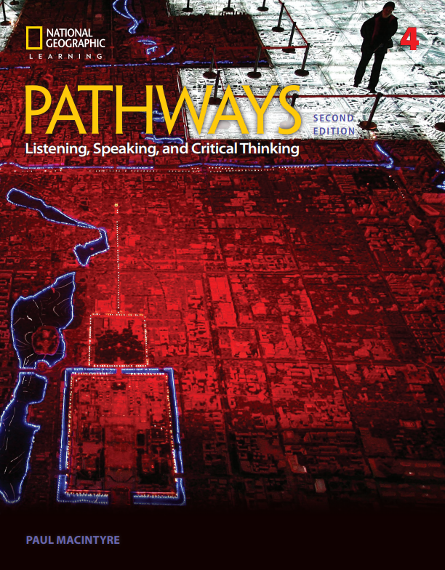


Correlation of
Pathways: Listening, Speaking, and Critical Thinking,
Level 4, 2/E,
by Paul MacIntyre, © 2018,
ISBN 13: 9781337407748
to
CASAS

Unit | CASAS
Unit 1 – Urban Challenges | 0.1.2 Understand or use appropriate language  for informational purposes (e.g., to identify, describe, ask for information, state needs, agree or disagree)  0.1.5 Interact effectively in the classroom  7.3.1 Identify a problem and its possible causes
Unit 2 – Protecting the Wild | 0.1.2 Understand or use appropriate language  for informational purposes (e.g., to identify, describe, ask for information, state needs, agree or disagree)  0.1.5 Interact effectively in the classroom  5.7.1 Interpret information related to environmental issues  5.7.3 Interpret information about issues related to natural sciences, such as biology
Unit 3 – Beauty and Appearance | 0.1.2 Understand or use appropriate language  for informational purposes (e.g., to identify, describe, ask for information, state needs, agree or disagree)  0.1.5 Interact effectively in the classroom  0.2.4 Converse about daily and leisure activities and personal interests
Unit 4 – Going Global | 0.1.2 Understand or use appropriate language  for informational purposes (e.g., to identify, describe, ask for information, state needs, agree or disagree)  0.1.5 Interact effectively in the classroom  4.1.9 Identify procedures for career planning, including self-assessment  4.5.1 Identify and use common tools, equipment, machines, and materials required for one's job
Unit 5 - Migration | 0.1.2 Understand or use appropriate language  for informational purposes (e.g., to identify, describe, ask for information, state needs, agree or disagree)  0.1.5 Interact effectively in the classroom  2.2.5 Use maps relating to travel needs,  including Internet-based map systems  5.2.3 Interpret information about world history
Unit 6 – Tradition and Progress | 0.1.2 Understand or use appropriate language  for informational purposes (e.g., to identify, describe, ask for information, state needs, agree or disagree)  0.1.5 Interact effectively in the classroom  2.7.1 Interpret information about holidays  2.7.2 Interpret information about ethnic groups, cultural groups, and language groups
Unit 7 – Money in our Lives | 0.1.2 Understand or use appropriate language  for informational purposes (e.g., to identify, describe, ask for information, state needs, agree or disagree)  0.1.5 Interact effectively in the classroom  1.5.1 Interpret information about personal and family budgets  1.5.1 Interpret information about personal and family budgets
Unit 8 – Health and Technology | 0.1.2 Understand or use appropriate language  for informational purposes (e.g., to identify, describe, ask for information, state needs, agree or disagree)  0.1.5 Interact effectively in the classroom  4.5.6 Demonstrate ability to select, set up, and apply appropriate technology for a given task  7.7.1 Identify common information and  communication technology and other electronic devices and their uses, and how they work together  5.7.4 Interpret information related to technological issues
Unit 9 – The Mysterious Mind | 0.1.2 Understand or use appropriate language  for informational purposes (e.g., to identify, describe, ask for information, state needs, agree or disagree)  0.1.5 Interact effectively in the classroom  5.7.3 Interpret information about issues related to natural sciences, such as biology
Unit 10 – The Future of Food | 0.1.2 Understand or use appropriate language  for informational purposes (e.g., to identify, describe, ask for information, state needs, agree or disagree)  0.1.5 Interact effectively in the classroom  1.2.8 Identify common food items  5.7.1 Interpret information related to environmental issues

