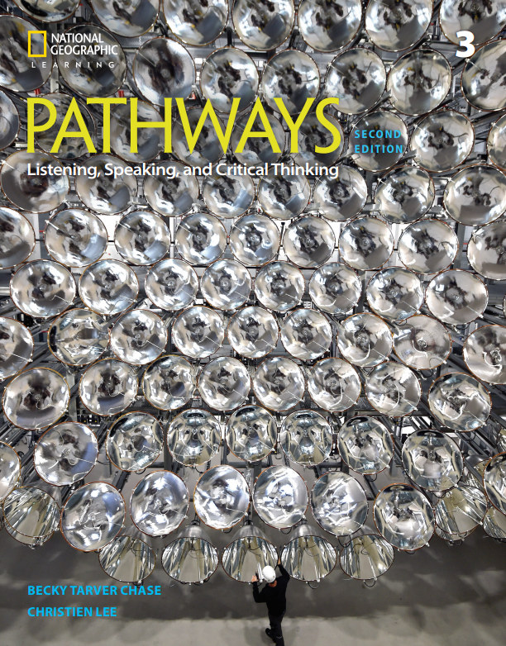


Correlation of
Pathways: Listening, Speaking, and Critical Thinking,
Level 3, 2/E,
by Becky Tarver Chase/ Christien Lee,
© 2018,
ISBN 13: 9781337407731
to
CASAS

Unit | CASAS
Unit 1 – The Science of Shopping | 0.1.2 Understand or use appropriate language  for informational purposes (e.g., to identify, describe, ask for information, state needs, agree or disagree)  0.1.5 Interact effectively in the classroom  1.2.5 Interpret letters, articles, and information about consumer-related topics
Unit 2 – Mother Nature | 0.1.2 Understand or use appropriate language  for informational purposes (e.g., to identify, describe, ask for information, state needs, agree or disagree)  0.1.5 Interact effectively in the classroom  5.7.3 Interpret information about issues related to natural sciences, such as biology
Unit 3 – On the Move | 0.1.2 Understand or use appropriate language  for informational purposes (e.g., to identify, describe, ask for information, state needs, agree or disagree)  0.1.5 Interact effectively in the classroom  5.2.1 Interpret information about U.S. history
Unit 4 – Our Changing Planet | 0.1.2 Understand or use appropriate language  for informational purposes (e.g., to identify, describe, ask for information, state needs, agree or disagree)  0.1.5 Interact effectively in the classroom  5.7.3 Interpret information about issues related to natural sciences, such as biology  2.8.2 Identify, evaluate, and access schools and other learning resources
Unit 5 - Making a Living, Making a Difference | 0.1.2 Understand or use appropriate language  for informational purposes (e.g., to identify, describe, ask for information, state needs, agree or disagree)  0.1.5 Interact effectively in the classroom  4.1.8 Identify common occupations and the skills and education required for them  5.6.4 Identify ways of conserving resources,  including recycling and using energy
Unit 6 – Design with Purpose | 0.1.2 Understand or use appropriate language  for informational purposes (e.g., to identify, describe, ask for information, state needs, agree or disagree)  0.1.5 Interact effectively in the classroom  0.2.4 Converse about daily and leisure activities and personal interests  7.3.2 Devise and implement a solution to an  identified problem
Unit 7 – Inspired to Protect | 0.1.2 Understand or use appropriate language  for informational purposes (e.g., to identify, describe, ask for information, state needs, agree or disagree)  0.1.5 Interact effectively in the classroom  5.7.1 Interpret information related to environmental issues
Unit 8 – Traditional and Modern Medicine | 0.1.2 Understand or use appropriate language  for informational purposes (e.g., to identify, describe, ask for information, state needs, agree or disagree)  0.1.5 Interact effectively in the classroom  3.3.1 Identify and use appropriate medications, including prescription, over-the-counter, and generic medications  3.6.3 Interpret information about illnesses,  diseases, and health conditions, and their symptoms
Unit 9 – Uncovering the Past | 0.1.2 Understand or use appropriate language  for informational purposes (e.g., to identify, describe, ask for information, state needs, agree or disagree)  0.1.5 Interact effectively in the classroom  5.2.3 Interpret information about world history
Unit 10 – Emotions and Personality | 0.1.2 Understand or use appropriate language  for informational purposes (e.g., to identify, describe, ask for information, state needs, agree or disagree)  0.1.5 Interact effectively in the classroom  0.1.8 Understand or use appropriate language to express emotions and states of being (e.g., happy, hungry, upset)

