
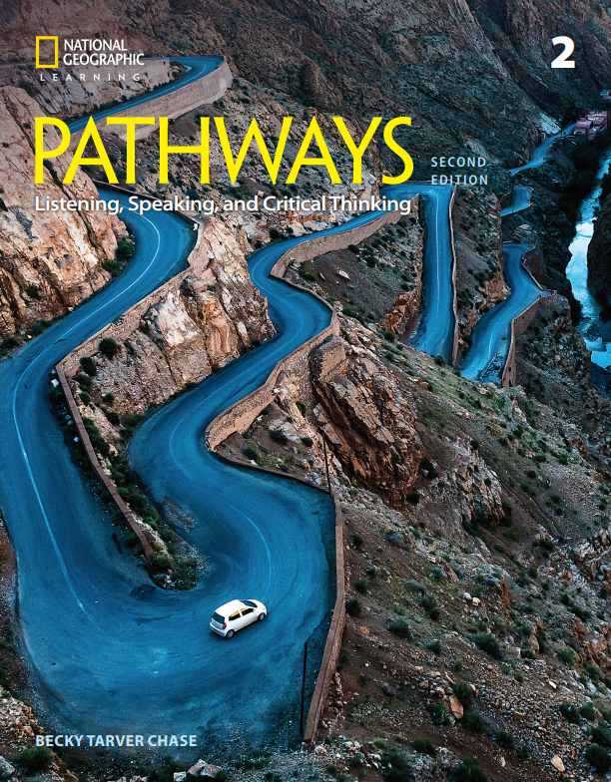

Correlation of
Pathways: Listening, Speaking, and Critical Thinking,
Level 2, 2/E,
by Becky Tarver Chase, © 2018,
ISBN 13: 9781337407724
to
CASAS

Unit | CASAS
Unit 1 – Healthy Lives | 0.1.2 Understand or use appropriate language  for informational purposes (e.g., to identify, describe, ask for information, state needs, agree or disagree)  0.1.5 Interact effectively in the classroom  3.5.2 Identify a healthy diet  3.5.9 Identify practices that help maintain good health, such as regular checkups, exercise, and disease prevention measures
Unit 2 – Technology Today and Tomorrow | 0.1.2 Understand or use appropriate language  for informational purposes (e.g., to identify, describe, ask for information, state needs, agree or disagree)  0.1.5 Interact effectively in the classroom  7.7.1 Identify common information and  communication technology and other electronic devices and their uses, and how they work together
Unit 3 – Culture and Tradition | 0.1.2 Understand or use appropriate language  for informational purposes (e.g., to identify, describe, ask for information, state needs, agree or disagree)  0.1.5 Interact effectively in the classroom  2.7.2 Interpret information about ethnic groups, cultural groups, and language groups
Unit 4 – A Thirsty World | 0.1.2 Understand or use appropriate language  for informational purposes (e.g., to identify, describe, ask for information, state needs, agree or disagree)  0.1.5 Interact effectively in the classroom  2.5.1 Locate and utilize services of agencies that provide emergency help  5.6.4 Identify ways of conserving resources,  including recycling and using energy efficiently
Unit 5 - Inside the Brain | 0.1.2 Understand or use appropriate language  for informational purposes (e.g., to identify, describe, ask for information, state needs, agree or disagree)  0.1.5 Interact effectively in the classroom  3.5.9 Identify practices that help maintain good health, such as regular checkups, exercise, and disease prevention measures  7.3.1 Identify a problem and its possible causes  7.3.2 Devise and implement a solution to an  identified problem
Unit 6 – Let’s Eat | 0.1.2 Understand or use appropriate language  for informational purposes (e.g., to identify, describe, ask for information, state needs, agree or disagree)  0.1.5 Interact effectively in the classroom  1.2.8 Identify common food items  3.5.2 Identify a healthy diet
Unit 7 – Our Active Earth | 0.1.2 Understand or use appropriate language  for informational purposes (e.g., to identify, describe, ask for information, state needs, agree or disagree)  0.1.5 Interact effectively in the classroom  5.7.3 Interpret information about issues related to natural sciences, such as biology
Unit 8 – Wonders from the Past | 0.1.2 Understand or use appropriate language  for informational purposes (e.g., to identify, describe, ask for information, state needs, agree or disagree)  0.1.5 Interact effectively in the classroom  5.2.3 Interpret information about world history
Unit 9 – Species Survival | 0.1.2 Understand or use appropriate language  for informational purposes (e.g., to identify, describe, ask for information, state needs, agree or disagree)  0.1.5 Interact effectively in the classroom  5.7.3 Interpret information about issues related to natural sciences, such as biology
Unit 10 – Entrepreneurs and Innovators | 0.1.2 Understand or use appropriate language  for informational purposes (e.g., to identify, describe, ask for information, state needs, agree or disagree)  0.1.5 Interact effectively in the classroom  7.3.1 Identify a problem and its possible causes  7.5.1 Identify personal values, qualities,  interests, abilities, and aptitudes

