
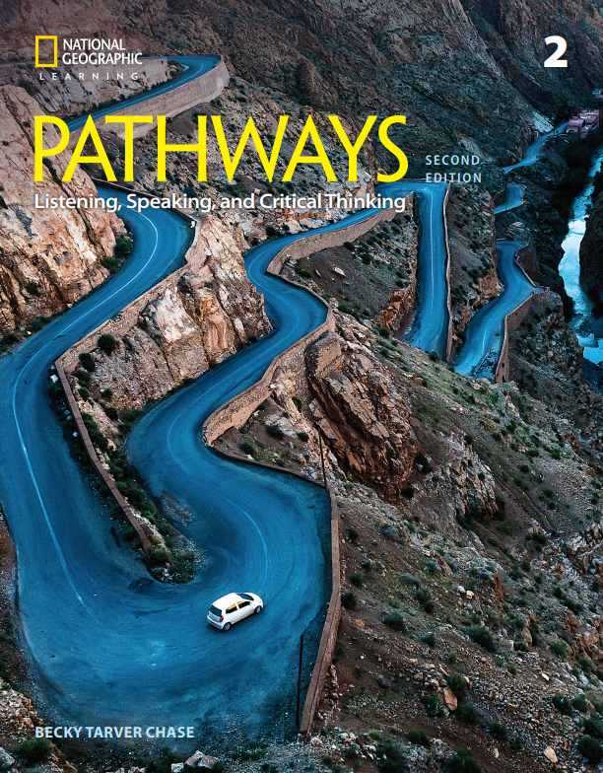

CASAS & CCRS light correlations
Please note: These correlations are selective and focus only on the skills most relevant to the CASAS and CCRS.
Pathways prepares students for the skills needed to increase CASAS scores and to meet requirements set forth in the Reading and Writing Standards of the CCRS.

Some examples are: using supporting details to find answers, comprehension questions on academic texts, identifying the main idea, distinguishing between points of view, comparing and contrasting, evaluating content from various types of media, analysis of infographics, writing with arguments to support claims, analysis with evidence (and specific test questions like exam-style multiple choice questions, sentence completion, numbered lines in text passages relating to questions) are just a few of the ways that Pathways helps to prepare adult learners for success in academic environments.

Correlation of
Pathways: Reading, Writing, and Critical Thinking,
Level 2, 2/E,
by Laurie Blass/ Mari Vargo, © 2018,
ISBN 13: 9781337407779
to
CASAS Competencies

Unit | CASAS
Unit 1 – Happiness | 0.1.2 Understand or use appropriate language  for informational purposes (e.g., to identify, describe, ask for information, state needs, agree or disagree)  0.1.5 Interact effectively in the classroom  0.1.8 Understand or use appropriate language to express emotions and states of being (e.g., happy, hungry, upset)  2.7.9 Identify similarities and differences between cultures and how these affect interpersonal and social relations and adaptation to a new cultural environment  5.7.5 Interpret information about issues related to social sciences, such as psychology
Unit 2 – Inventive Solutions | 0.1.2 Understand or use appropriate language  for informational purposes (e.g., to identify, describe, ask for information, state needs, agree or disagree)  0.1.5 Interact effectively in the classroom  7.3.1 Identify a problem and its possible causes  7.3.2 Devise and implement a solution to an  identified problem  7.3.4 Use problem-solving strategies, such as breaking down the problem into component parts and generating alternative or creative solutions
Unit 3 – Connected Lives | 0.1.2 Understand or use appropriate language  for informational purposes (e.g., to identify, describe, ask for information, state needs, agree or disagree)  0.1.5 Interact effectively in the classroom  4.9.3 Identify sources of information and assistance, and access resources within a system  7.4.4 Identify, evaluate and use appropriate  informational resources, including the Internet
Unit 4 – Saving Our Seas | 0.1.2 Understand or use appropriate language  for informational purposes (e.g., to identify, describe, ask for information, state needs, agree or disagree)  0.1.5 Interact effectively in the classroom  2.7.3 Interpret information about social issues  5.7.1 Interpret information related to environmental issue
Unit 5 - Memory and Learning | 0.1.2 Understand or use appropriate language  for informational purposes (e.g., to identify, describe, ask for information, state needs, agree or disagree)  0.1.5 Interact effectively in the classroom  7.4.3 Identify and use strategies for remembering information  5.7.5 Interpret information about issues related to social sciences, such as psychology
Unit 6 – Animals and Medicine | 0.1.2 Understand or use appropriate language  for informational purposes (e.g., to identify, describe, ask for information, state needs, agree or disagree)  0.1.5 Interact effectively in the classroom  5.7.1 Interpret information related to environmental issues  5.7.3 Interpret information about issues related to natural sciences, such as biology
Unit 7 – Nature’s Fury | 0.1.2 Understand or use appropriate language  for informational purposes (e.g., to identify, describe, ask for information, state needs, agree or disagree)  0.1.5 Interact effectively in the classroom  2.3.3 Interpret information about weather conditions
Unit 8 – Building Wonders | 0.1.2 Understand or use appropriate language  for informational purposes (e.g., to identify, describe, ask for information, state needs, agree or disagree)  0.1.5 Interact effectively in the classroom  5.2.3 Interpret information about world history
Unit 9 – Form and Function | 0.1.2 Understand or use appropriate language  for informational purposes (e.g., to identify, describe, ask for information, state needs, agree or disagree)  0.1.5 Interact effectively in the classroom  5.7.3 Interpret information about issues related to natural sciences, such as biology
Unit 10 – Smart Advice | 0.1.2 Understand or use appropriate language  for informational purposes (e.g., to identify, describe, ask for information, state needs, agree or disagree)  0.1.5 Interact effectively in the classroom  4.1.3 Identify and use sources of information  about job opportunities such as job descriptions, job ads, and online searches, and about the job market  5.7.4 Interpret information related to technological issues  5.8.2 Interpret information on economic issues and trends

